M3.2 Assignment
Course: CSD310 – 340A
Prepared By: Mirach Erkol
Date of Report: 11/9/2025

https://github.com/Mikey5007/csd-310.git

M2.3 Assignment: 1NF, 2NF, 3NF
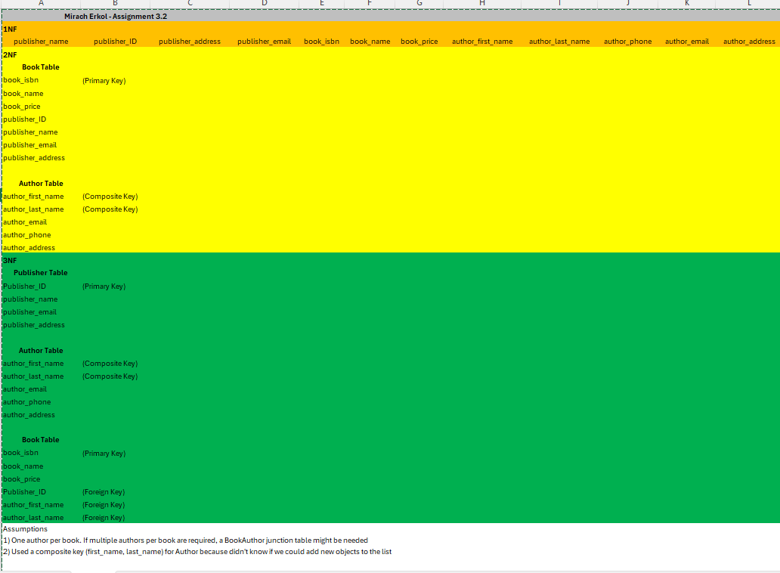

Mikey5007/csd-310: CSD

